Лабораторная работа №2

Выполнил: студент группы «ПМИ-РКС-20» Каньшин Владислав Антонович

№1 (2.2)

select \*

from customers

where city not in (‘Ковров’)

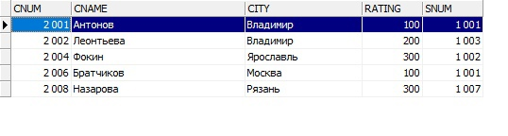

№2 (2.5)

select \*

from orders

where odate = '03.10.2006' or odate = '04.10.2006'

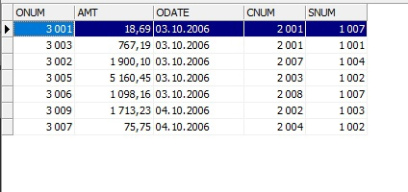

№3 (3.3)

select min (amt)

from orders

where cnum = 2008

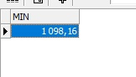

№4 (3.4)

select avg(amt)

from orders

where cnum = 2003 or cnum = 2007

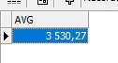

№5(4.2)

select snum, count(cnum)

from orders

group by snum

order by snum

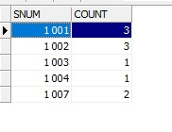

№6 (5.3)

select salespeople.sname, max(orders.amt)

from orders

left join salespeople on orders.snum = salespeople.snum

group by sname

order by sname

